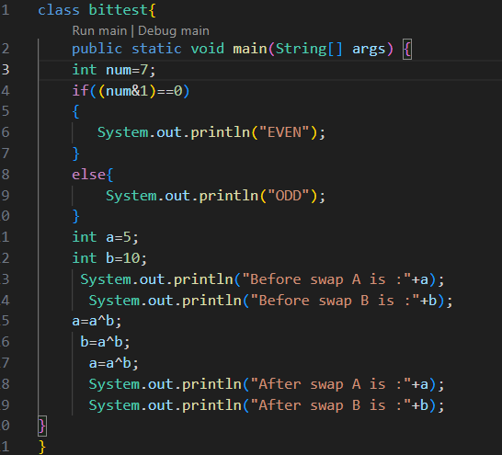
Output
Bitwise operator testsss
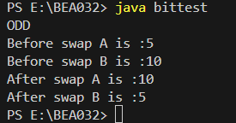

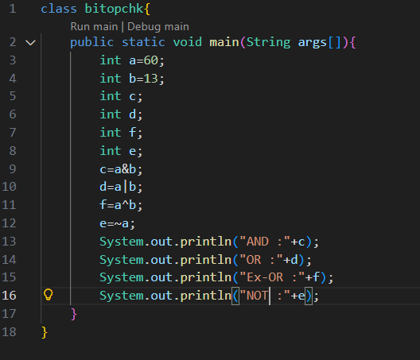
BASIC BITWISE OPERATOR
OUTPUT
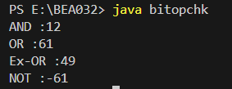

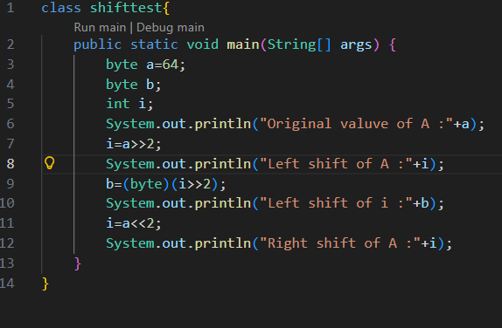
Shifting operation
Output
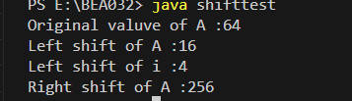

import java.util.Scanner;
class P1
{
public static void main(String args[])
{
Scanner sc=new Scanner(System.in);
char c;
System.out.print("Enter a character : ");
c=sc.next().charAt(0);
switch(c)
{
default:
System.out.println("Not Vowelll : " + c);
break;
case 'a':
case 'e':
case 'i':
case 'o':
case 'u':
case 'A':
case 'E':
case 'I':
case 'O':
case 'U':
System.out.println("Vowel : " + c);
break;
}
}
}

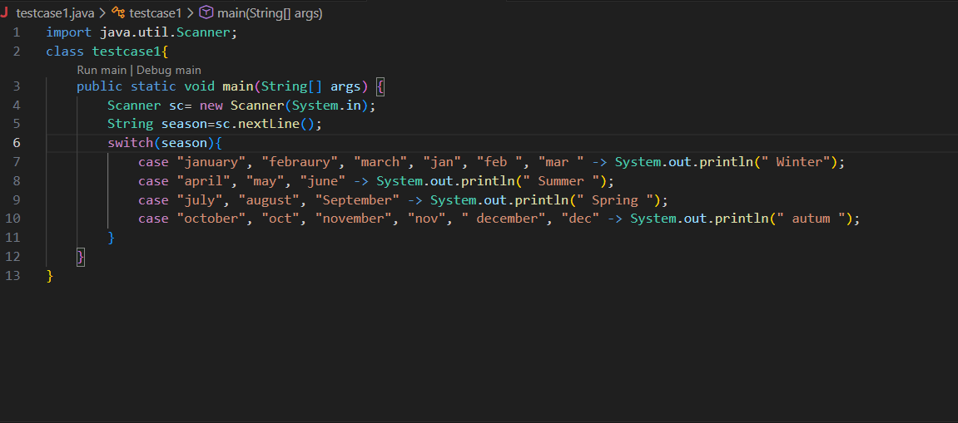

Output

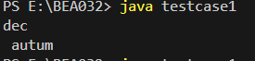

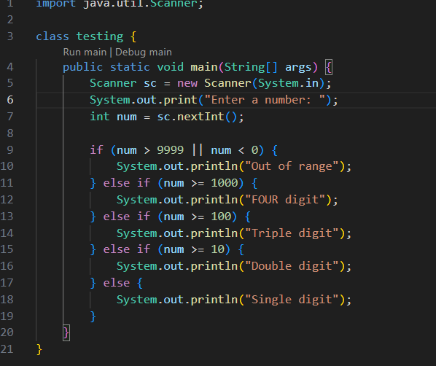
Output
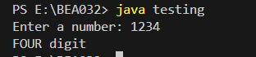

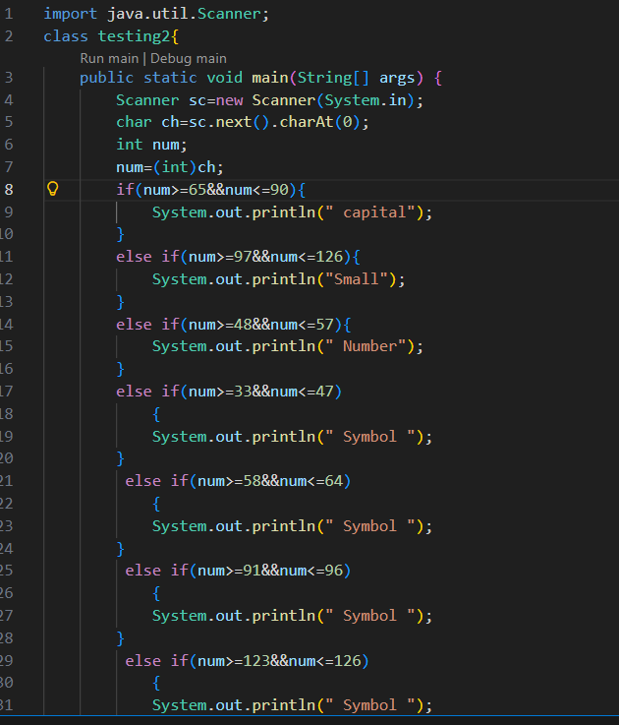
Output
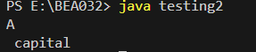
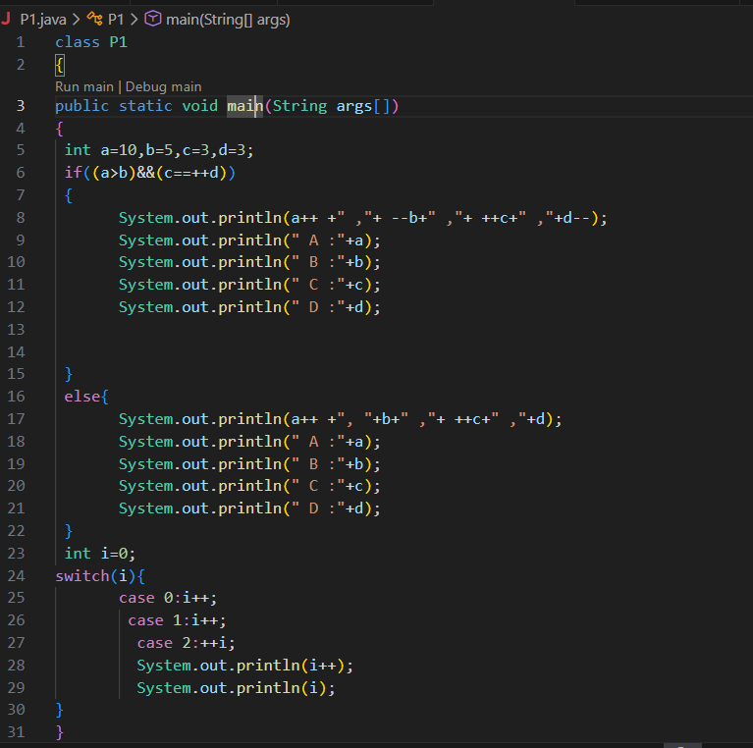
Output
